FENG703 Biochemical process modelling – assignment 1

Question 1

a)

**F**

**V0**

Rate of change of volume is dV/dt = F

So total mass balance is V= F*t + V0

b)

Rate of substrate consumption is k1S.V

Rate substrate generation is FSf

So d(VS) = FSf – k1SV  
 t

V(ds/dt) + s(dV/dt) = FSf - k1SV

V(ds/dt) + FS = FSf - k1SV

V(ds/dt) = F(Sf – S) - k1SV

(ds/dt) = F/V(Sf – S) - k1S

Question 2

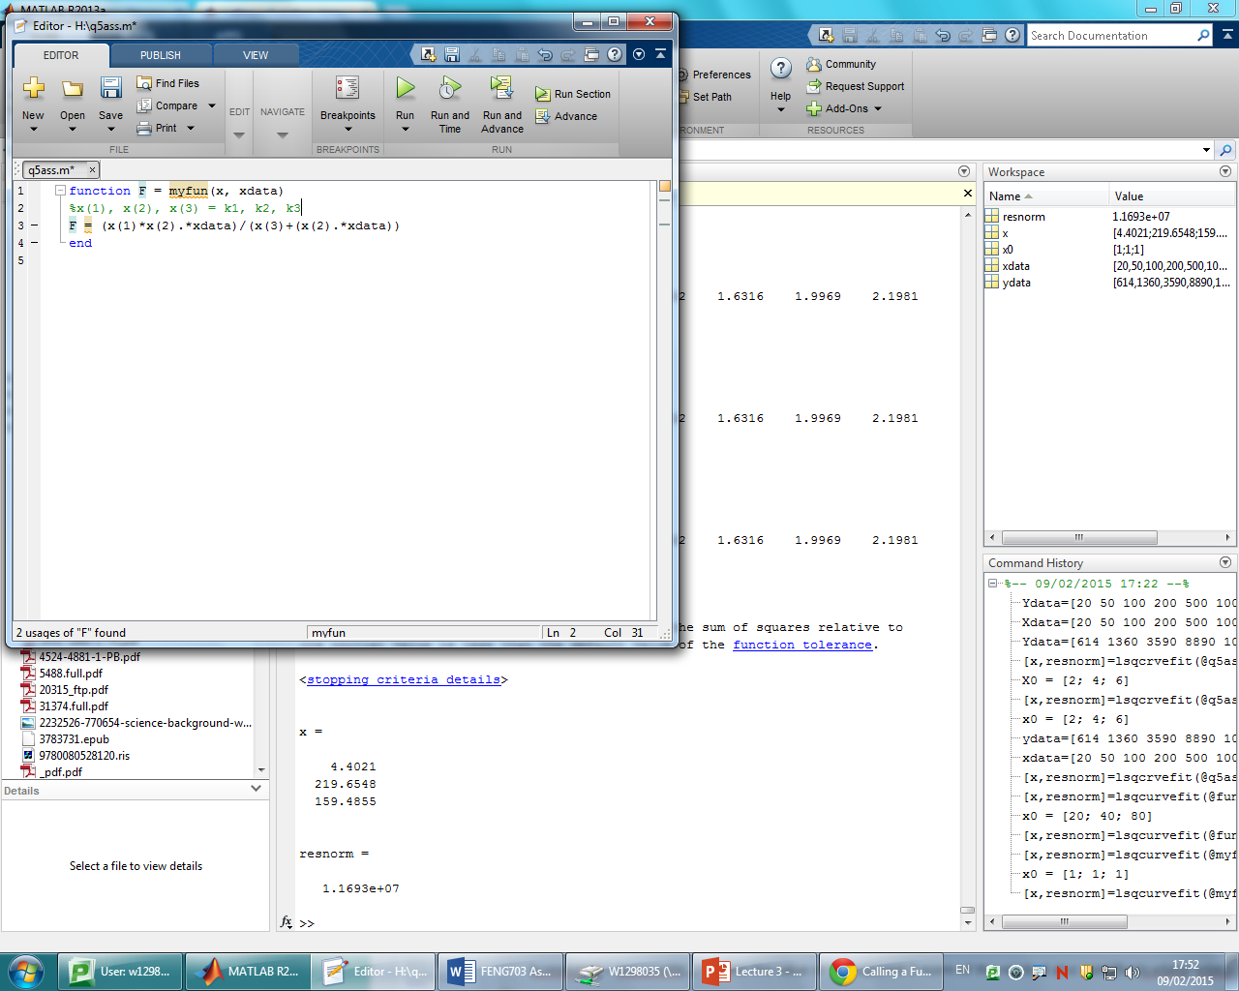

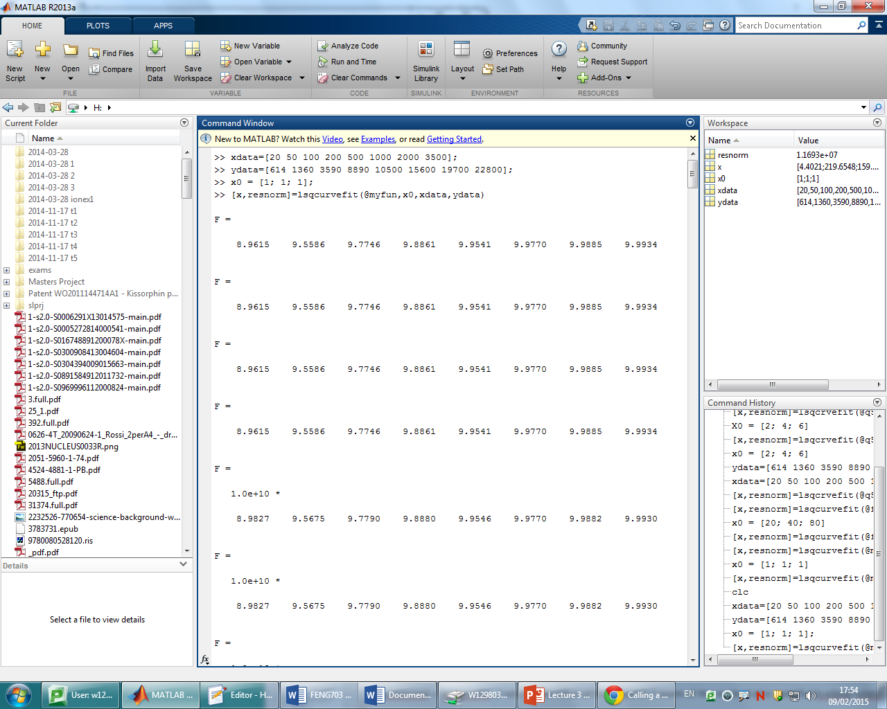

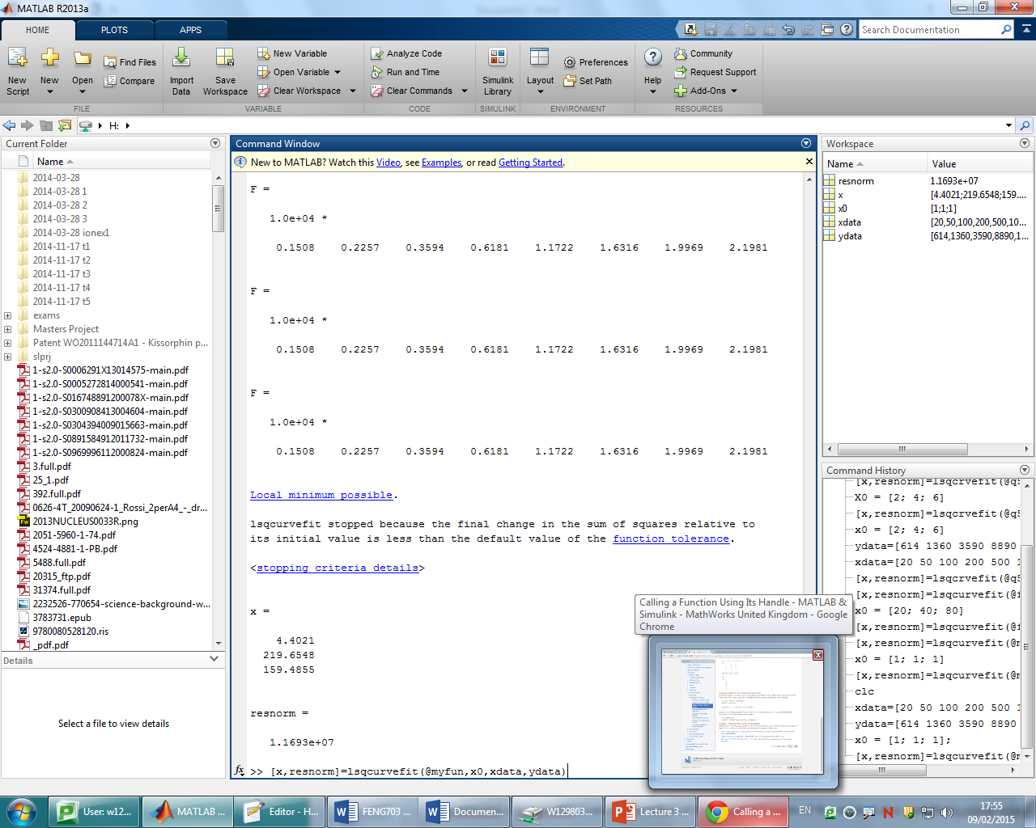

So K1 = 4.40, K2 = 219.65, K3 = 159.48

Question 3





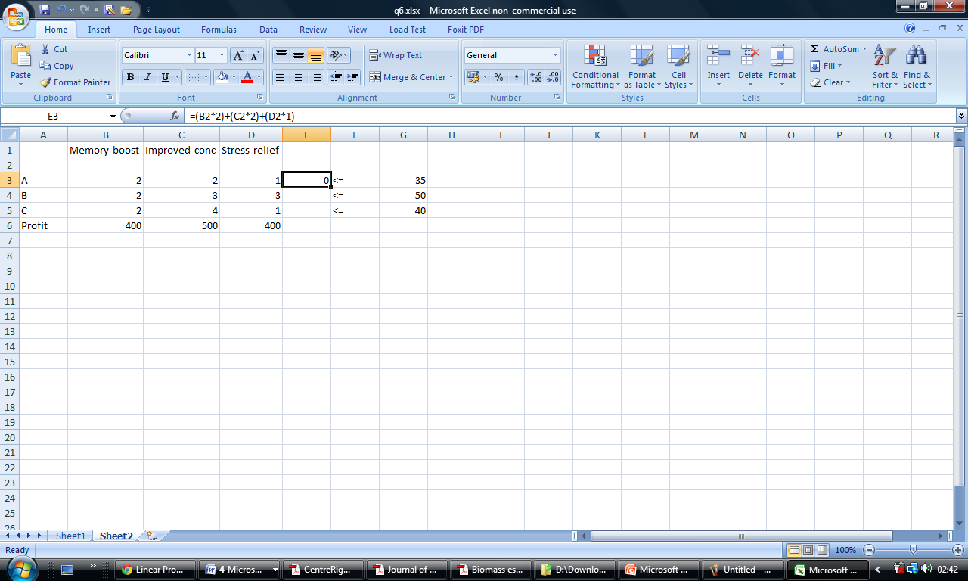

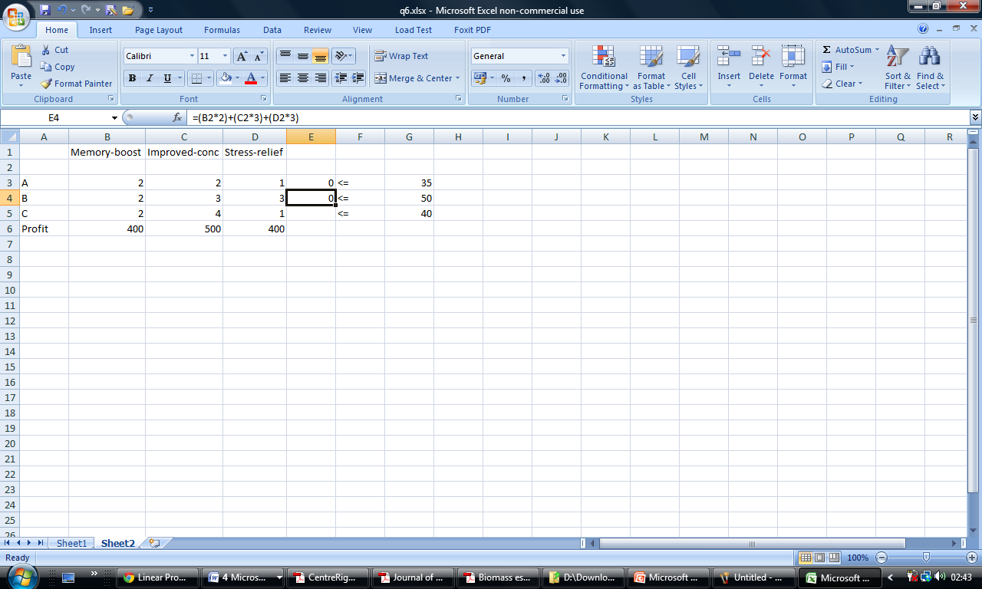

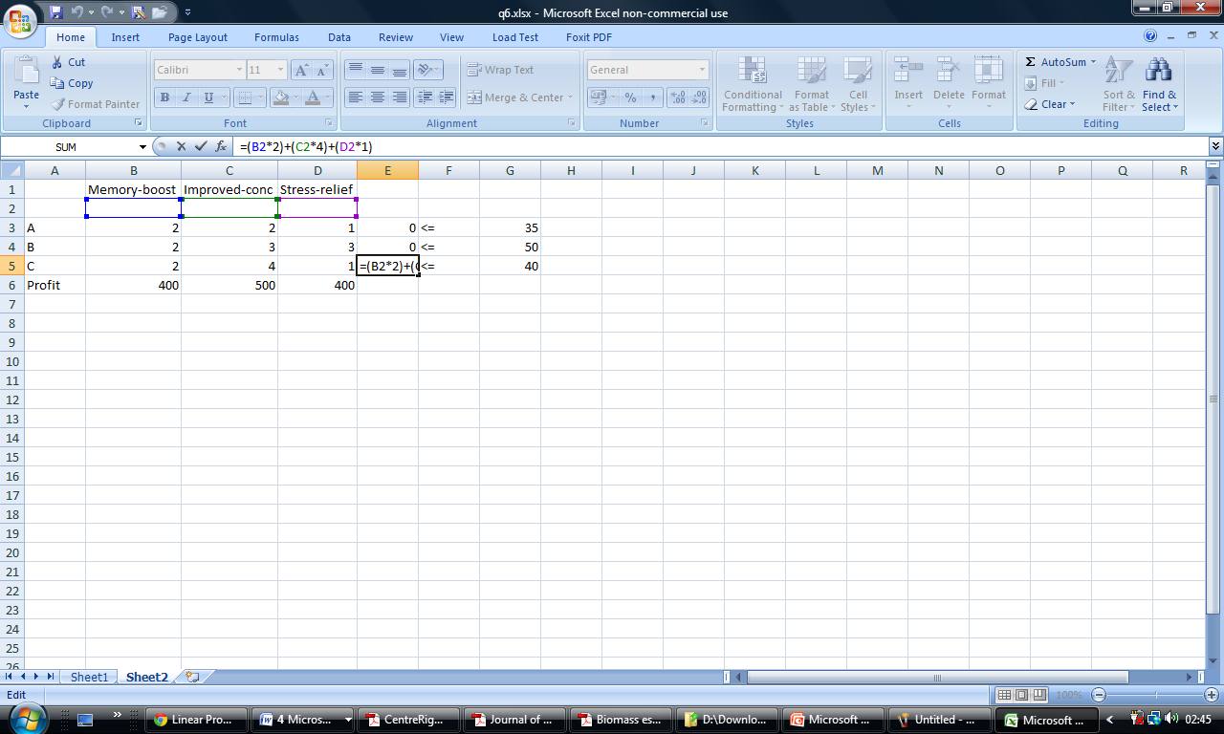

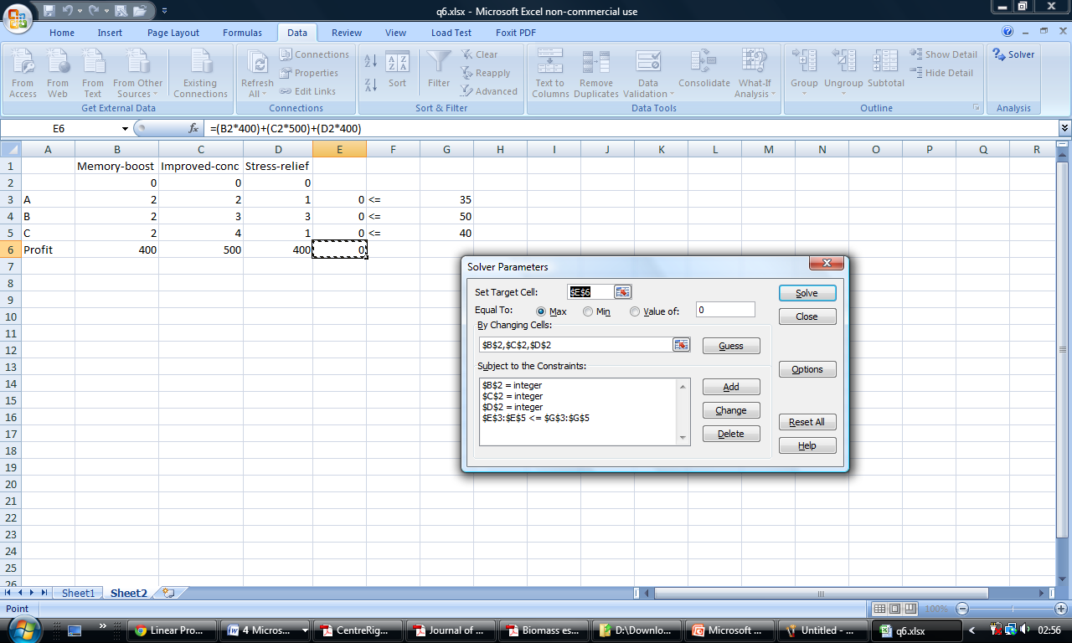

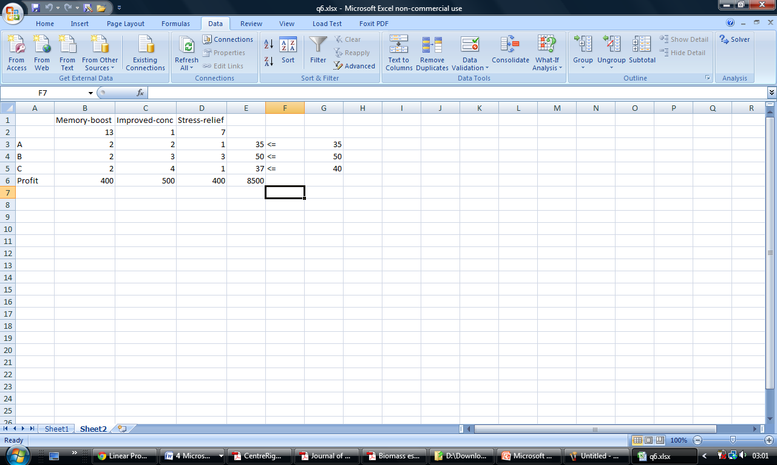

Therefore in order to maximise its profit the company should produce 13 batches of Memory boost protein, 1 batch of Improved concentration protein and 7 batches of stress relief protein.

Question 7

a)

As growth rate is highest for highest substrate concentration Dopt should be worked out for the first stage of the chemostat

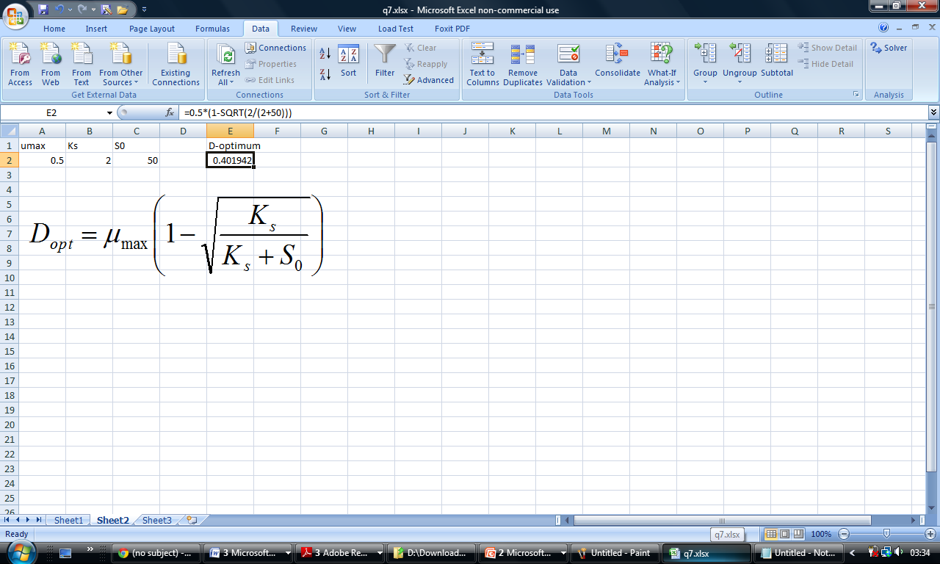

So the maximum dilution rate for optimal growth is Dmax =0.402 L/h

b

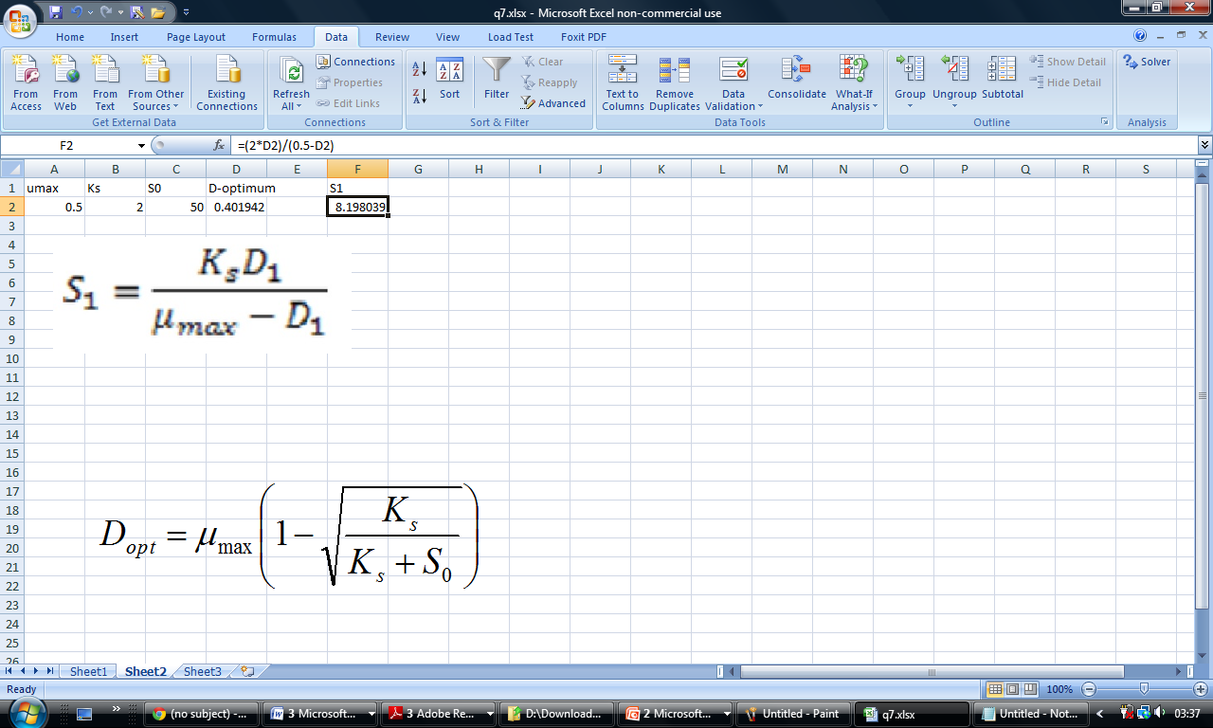

So the level of substrate leaving the first reactor is S1 = 8.20g



Therefore amount of biomass leaving first reactor is X1 = 41.80g

C

Equations are

  

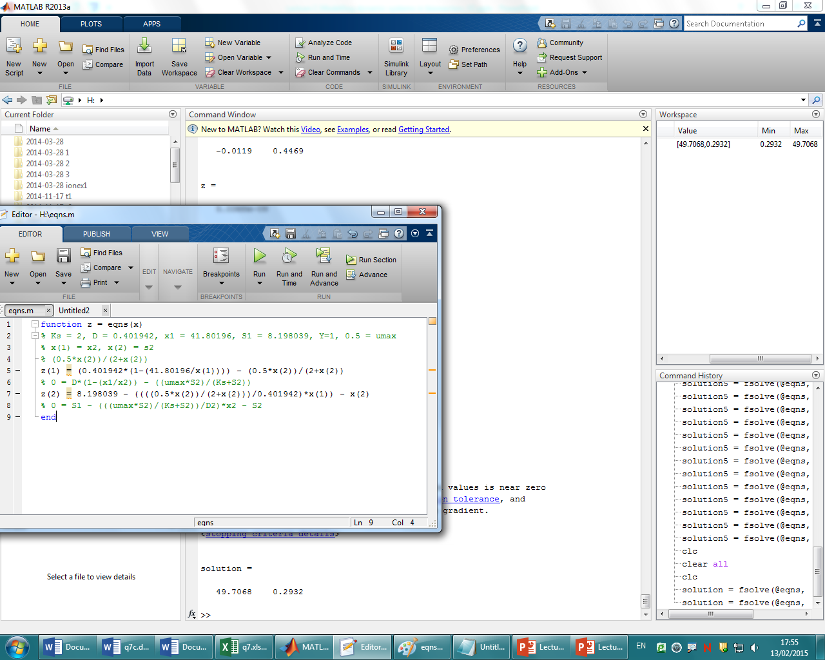

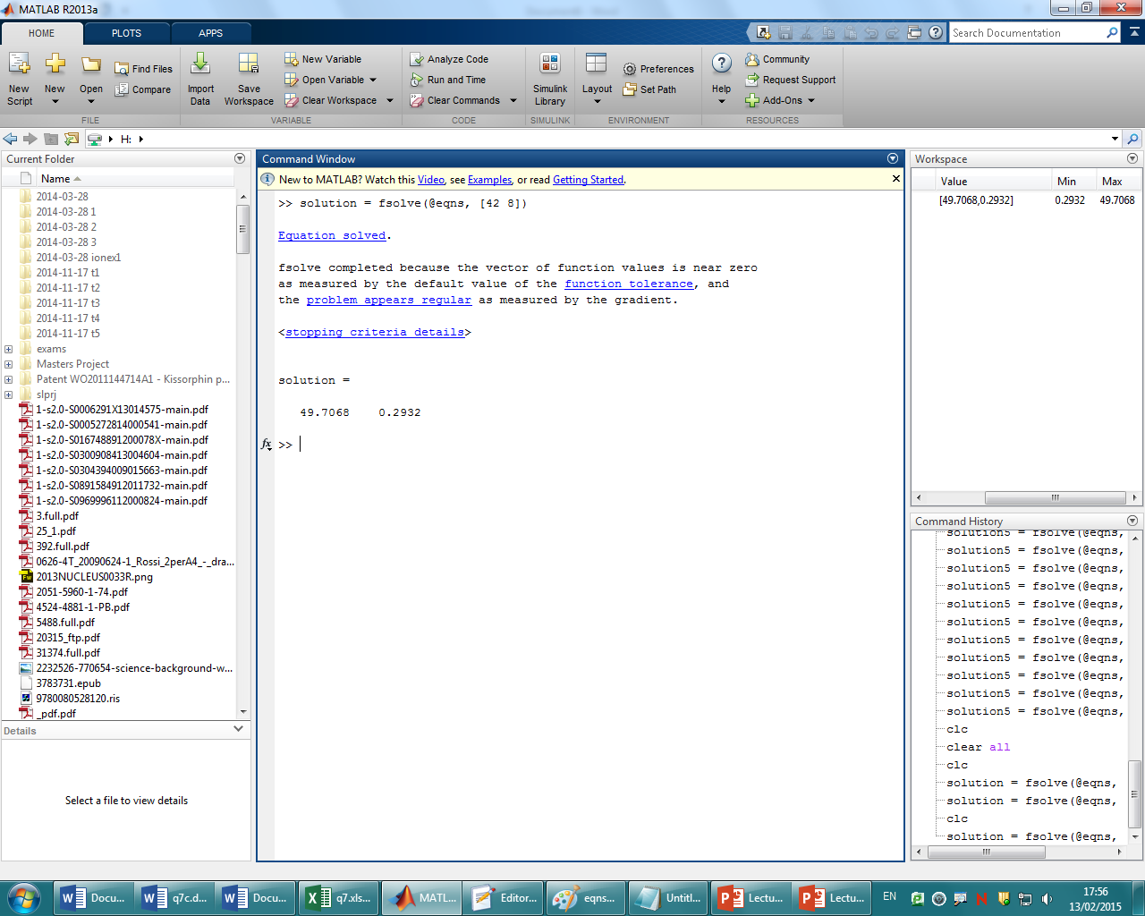

So X2 = 49.71g, S2=0.29g

Question 8

Equations are:

Yx/s = Xf – X0/S0-Sf = (20.09 - 5.01)/(125 - 3.71) = 0.124

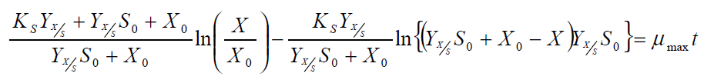 So:





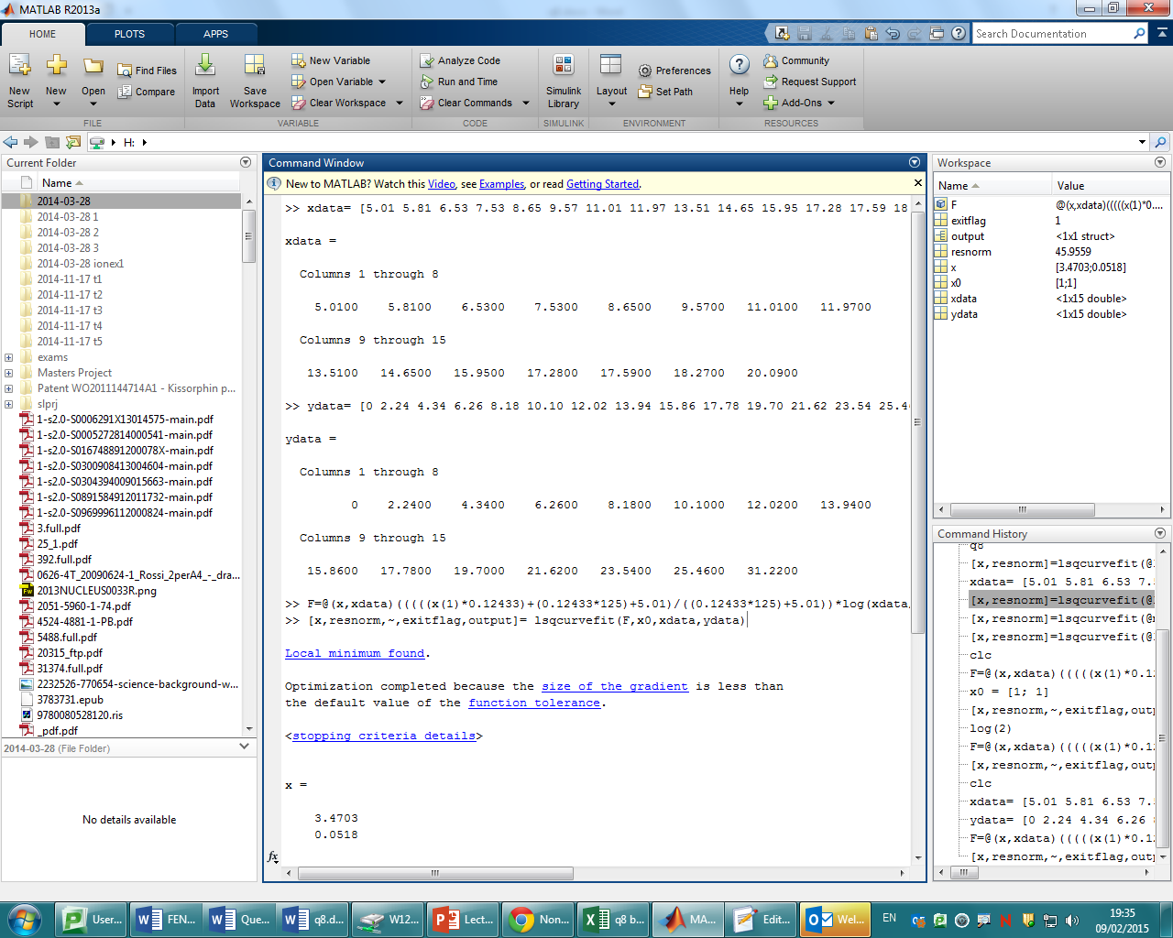

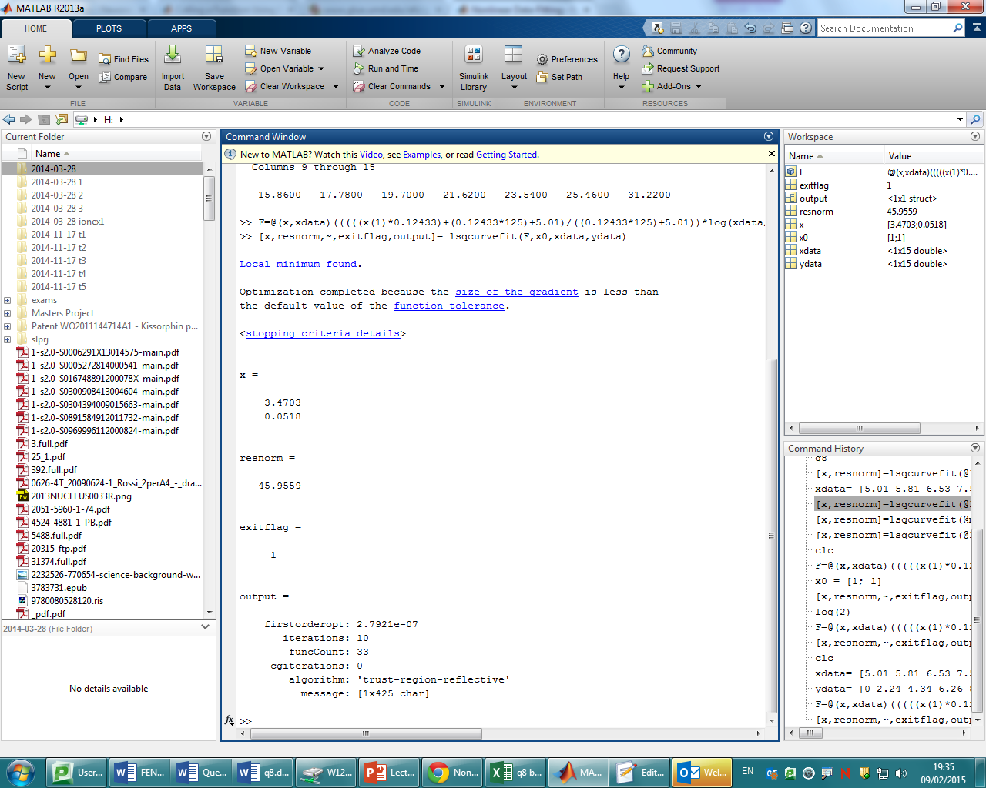

Therefore Ks = 3.47 g.dm-3, μmax = 0.0518 hr-1

**References**

Skelton, R.E., Han, J., de Oliveira, M., System *Modelings and Model Reduction, the Handbook of Smart Systems and Materials*, Institute of Physics (IOP)

Michael J. Crawley, Statistics: *An Introduction Using R Paperback,* Wiley-Blackwell; 1 edition (11 Mar. 2005)

Mary C. Hill, METHODS AND GUIDELINES FOR EFFECTIVE MODEL CALIBRATION 1998 U.S. GEOLOGICAL SURVEY WATER-RESOURCES INVESTIGATIONS REPORT 98-4005

Lennart Ljung, *Perspectives on System Identification Annual Reviews in Control Volume* 34, Issue 1, April 2010, Pages 1–12

Roger Levy, *Parameter Estimation, with R code, Probabilistic Models* in the Study of Language (unpublished 2012)

Hacking, Ian. 1983. Representing *and Intervening. Introductory Topics in the Philosophy of Natural Science.* Cambridge University Press

Oliver Hädicke, Steffen Klamt, *CASOP: A Computational Approach for Strain Optimization aiming at high Productivity,* Journal of Biotechnology 147 (2010) 88–101

Krist V. Gernaey, Anna Eliasson Lantz, Par Tufvesson, John M. Woodley, Gurkan Sin, *Application of mechanistic models to fermentation and biocatalysis for next-generation processes*, Trends in Biotechnology 28 (2010) 346–354

Desgrange C, Georges M, Vergoignan C, Durand A*, Biomass estimation in Solid state fermentation, Applications of Microbial technology* (1991) 35: 206-209